Quantified Student

General Usability Test Findings



Created by G. Malisz

Spis treści

1. Version History 1

2. Overview 1

3. Layout 1 2

4. Layout 2 2

5. Student Preferences 2

6. Data Sources Findings 4

7. Conclusion 5

8. Definitions, Acronyms, and Abbreviations 5

# Version History

|  |  |  |  |
| --- | --- | --- | --- |
| Version | Date | Author | Comment |
| 0.1 | 07.06.2023 | G. Malisz | First iteration of this document. Overview, Layouts, Student Preferences, Data Sources Findings and Conclusion. |

# Overview

The general usability test for the student performance dashboard primarily focused on selecting the best dashboard layout and confirming the reliability and accuracy of the data sources. The test aimed to gather feedback from stakeholder and end-users regarding the usability, clarity, and effectiveness of the different layout options. Participants were encouraged to explore the dashboard prototypes, providing valuable insights on the intuitiveness of the navigation, the visual presentation of data, and the overall user experience. Additionally, the usability test ensured that the data sources integrated into the dashboard were reliable, up-to-date, and aligned with the stakeholder expectations. By validating the layout design and data sources in the initial usability test, the project team could proceed with confidence in further refining and enhancing the student performance dashboard layout designs.

General Usability Test can be found in the **QS - Dashboard General Usability Test.pdf** file

# Layout 1

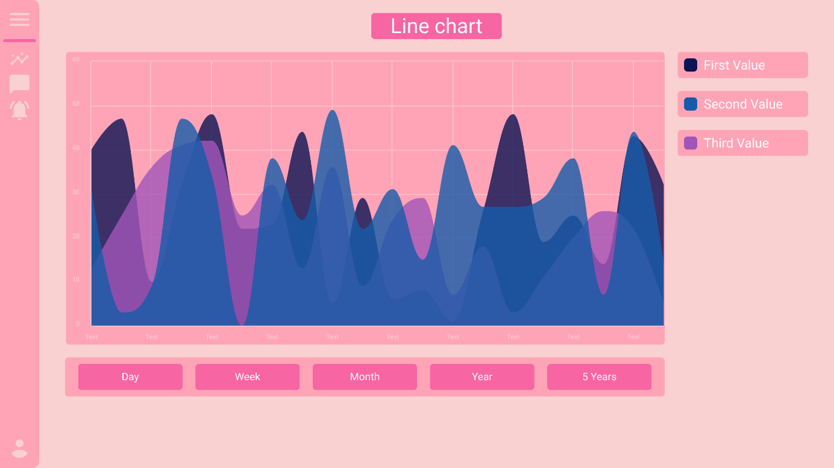

# Layout 2

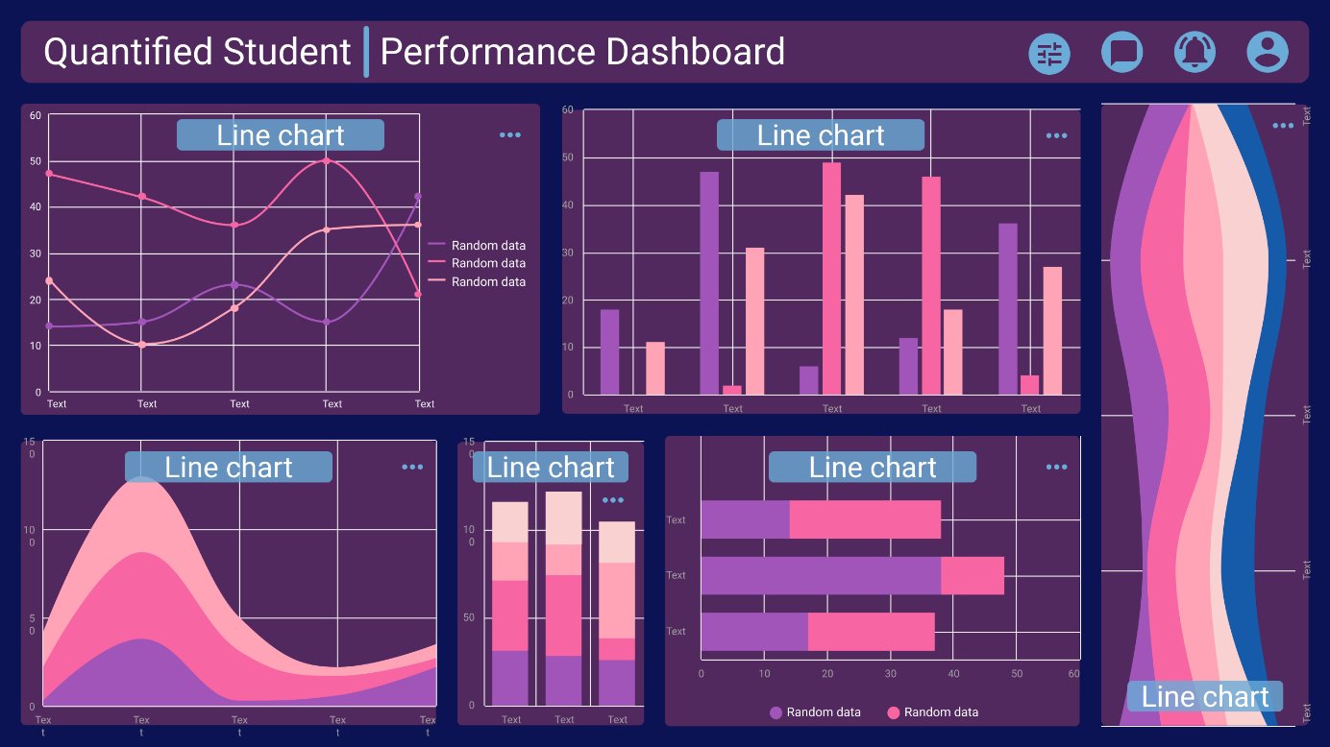

# Student Preferences

Based on the feedback gathered from the students, Layout 2 was chosen as the preferred option for the student performance dashboard. The majority of the students expressed their approval for Layout 2, citing its intuitive structure, quick access to relevant information, and interactive elements. However, it was noted that some refinements would be necessary to align it more closely with the specific requirements and preferences of the students. Taking into consideration the valuable input received, the development team will work on refining Layout 2 to ensure it fully meets the students' expectations and delivers an optimal user experience. By incorporating these refinements, the student performance dashboard will be further enhanced, providing a tailored and user-friendly interface for students to track and analyse their performance effectively.

The snippets from the General Usability Test Findings are displayed below. Whole General Usability Test Findings can be found in the **QS - General Usability Test Answers.pdf**

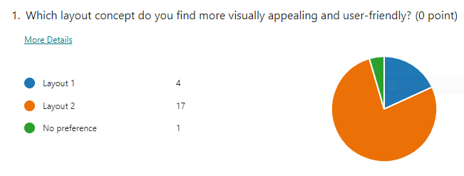

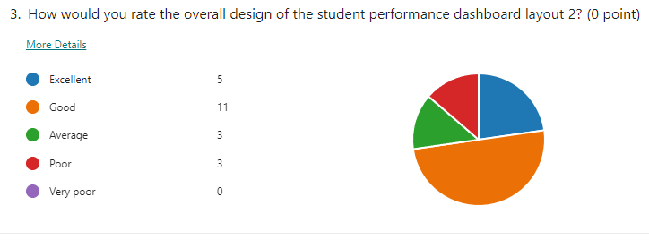

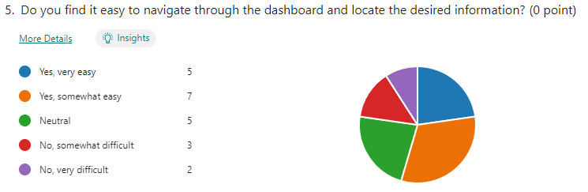

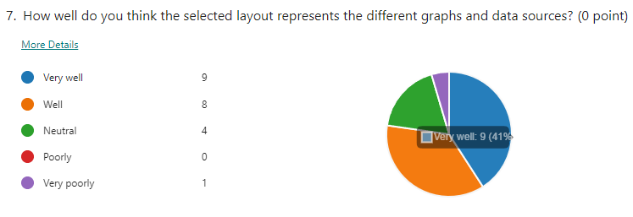

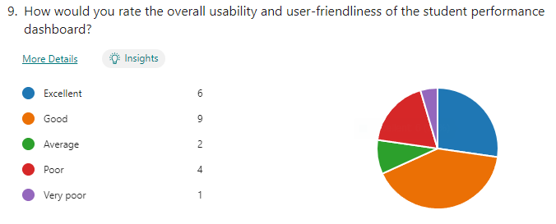

# Data Sources Findings

Based on the feedback gathered from the students during the General Usability Test, several data sources emerged as the most important based on positive responses from 50% or more of the students. These data sources include weather, sleep, working at school, working at home, and stress. The students highlighted the significance of these factors in understanding their performance and identifying potential correlations. While student opinions provide valuable insights, it is important to note that they cannot be the sole determining factor when selecting data sources. To ensure a comprehensive and accurate analysis, it is recommended to consult with experts who specialize in human behaviour and performance. Their expertise can help validate the chosen data sources and provide additional insights into the impact of these factors on student performance. By incorporating both student feedback and expert guidance, the student performance dashboard can deliver a robust and well-rounded representation of the factors influencing academic progress.

The percentage breakdown in student responses for all questions can be found in the file named **QS - General Usability Test Answers.pdf**

# Conclusion

The findings from the General Usability Test regarding the layouts and data sources have provided valuable insights for the development of the student performance dashboard and the future development of the Quantified Student System. The feedback obtained from the test participants has helped establish a clear direction for the dashboard development, with Layout 2 being chosen as the preferred option. Additionally, the identification of important data sources, such as weather, sleep, working at school, working at home, and stress, will guide the integration of these factors into the system's analytical capabilities. These findings will play a pivotal role in shaping the ongoing development efforts, ensuring that the Quantified Student System effectively addresses the needs and preferences of the students, ultimately enhancing their academic experience and performance.

# Definitions, Acronyms, and Abbreviations

|  |  |
| --- | --- |
| Abbreviation | Meaning |
| QS | Quantified Student |
| Microservice | Small independent services that communicates with Application |